OPERATOR DESIGN

Heres all the things we need designs for

1: identity-

2: dense

3: conv2d

4: relu-

5: softmax-

6: maxpool

7: zero padding layer

8: batch normalization

9: avg pooling 2d

10: global avg pooling

11: prelu

12: sigmoid-

13: softplus-

14: swish-

15: softsign-

16: tanh-

UI categories:

"classification" with softmax and dense

1. "image processing" with Conv2d, zeropadding, maxpool, avgpool, globalavgpool, batchnorm,

"sigmoid activations" with sigmoid, softsign, tanh

1. "linear activations": with identity, relu, prelu, softplus, swish

Heres what we already have

1. identity

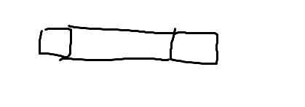

1. dense

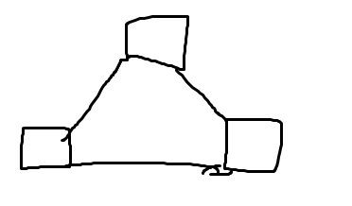

1. conv 2d

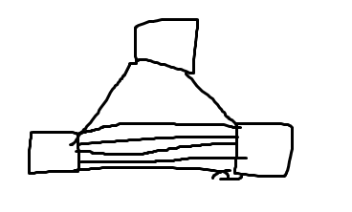

1. relu

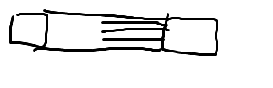

1. softmax

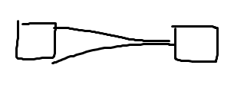

1. maxpool

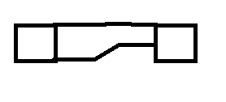

some of these may be subject to change (maxpool and relu especially)

## Categories

Classic, parameter rich layers

dense,

conv2d

Identity

identity

negative is 0, positive is x; type of activations

relu

prelu

softplus

swish

sigmoid type activation

sigmoid

softsign

tanh

condensing image to lower resolution

maxpool

avg pooling 2d

global avg pooling

preprocessing image

7: zero padding layer

8: batch normalization

signal accentuation

softmax

# MAYBE

Zero padding layer,

it add zeroes to the boundaries increasing size of image, so maybe

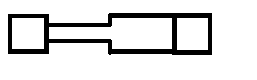

but the softmax block and gives the impression that lack of ‘color’ (the lil tape thing that connects the tensors) means zero

Maxpool

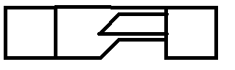

maxpool takes the max in a small region of an image,

maybe we can associate vertical height with magnitude of input

then AVGPOOL would look like:

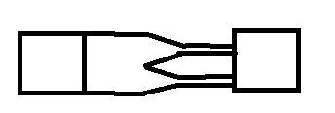

If we are to associate height with input value, then softmax would look like:



Prelu



Should be similar to relu however i dont think theres a parameter that can be shown visually for the difference between them. Maybe just reverse the design?

yeah it would be a bit annoying to add a new tensor and make it a binary operator

Softplus



If its referred to as the smooth version of relu then maybe instead of lines we can incorporate curves or circles? Make it look wavy or like swiss cheese? yeah thats probably the way to go. We gotta do that for all of the curvy relus tho, i think swish is a curvy relu as well

Swish



Another smooth relu?

I think we gotta rethink these

PRelu

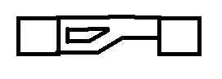

Relu

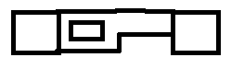

Diff between swish and softplus:

SIGMOID TYPE ACTIVATIONS

we need an iconic form for these three to base them off of

maybe maybe

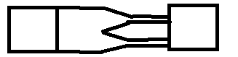

maybe for avgpool, maxpool, we split it in 3?









sigmoids:

Sigmoid:

Between 0 and 1

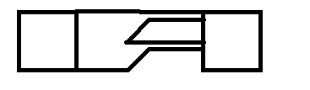

Softsign:

Between -1 and 1?

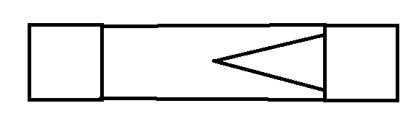

Tanh:

Between -1 and 1

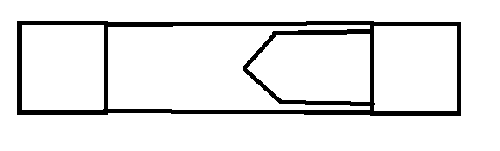

diff between softsign and tanh: “ **tanh converges exponentially whereas softsign converges polynomially**.”

yeah softsign seems to approach 1 very slowly. Okay that works.

and (-1, 1) be like:



OR MAYBE FOR MAXPOOL

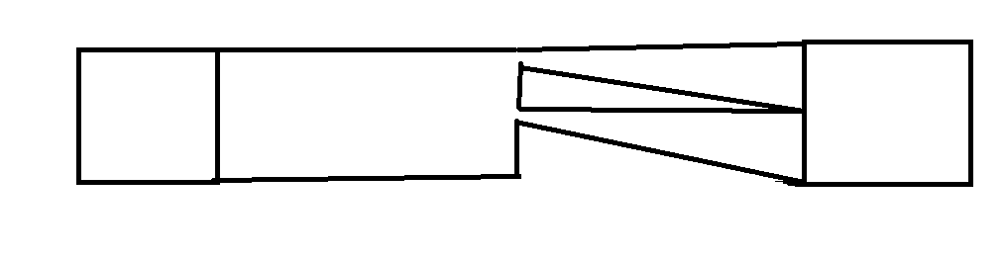

this design emphasizes the ‘hard cuttof’ that happens in max pool. max pool completely ditches any value which isnt the max in a region.

we could also do 3 splits instead of 2.

I like this

then Avgpool

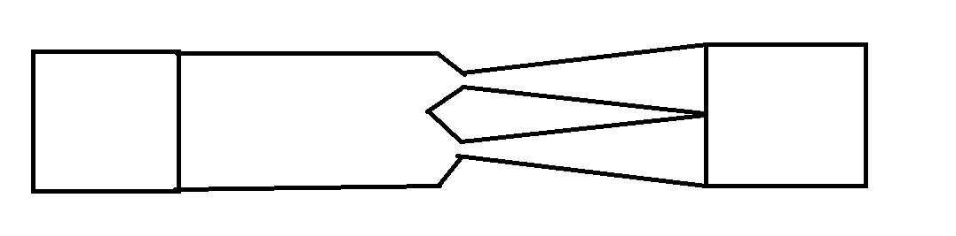

and then global avg pool

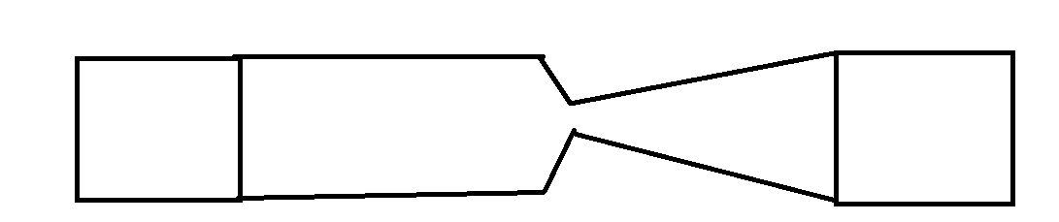

bim bam boom

preprocessing image

7: zero padding layer

8: batch normalization

Zero padding layer,

it add zeroes to the boundaries increasing size of image, so maybe



Batch Normalization

this ones weird, it recenters and renormalizes the input

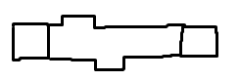

maybe something weird like this, it starts out junky and off center and then becomes centered

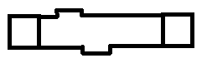

FIRST PASS IDEAS

1: identity-

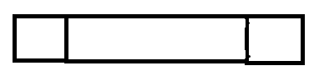

2: dense



3: conv2d



4: relu-

5: softmax- max the skinnyness happen earlier, so we dont confuse it with relu



6: maxpool



7: zero padding layer



8: batch normalization



9: avg pooling 2d



10: global avg pooling



11: prelu

12: sigmoid-



13: softplus-

14: swish-

15: softsign-



16: tanh-



Random relu ideas







REMOVE CUTOUT SHAPE FOR BELOW:

PRelu



Relu



swish:

sorry looks like shit.

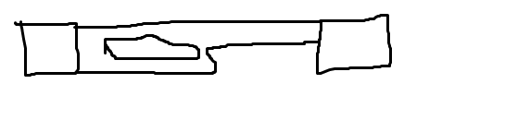

softplus:

curvy

(diff):